OP1 and OP2 Developments

In OP2 application, project register we added cost columns (OP1(LC), OP2(LC), OPEX(LC), OP1(CHF), OP2(CHF), OPEX(CHF), OP1(USD), OP2(USD), OPEX(USD)) in Cost element data. And removed all the capex columns.

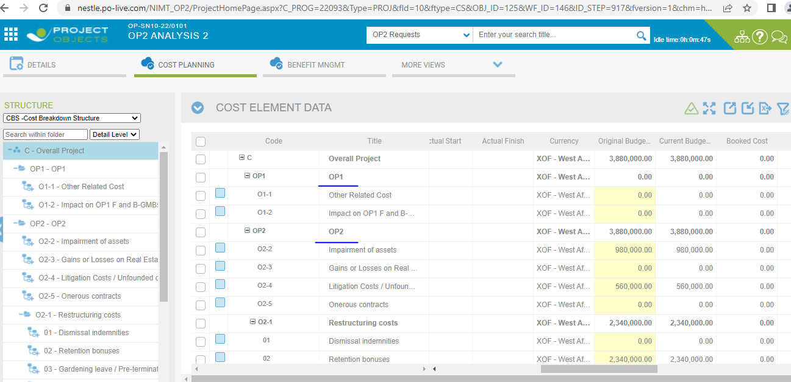

* User set the budget of their in all investment type of OP1 and OP2.

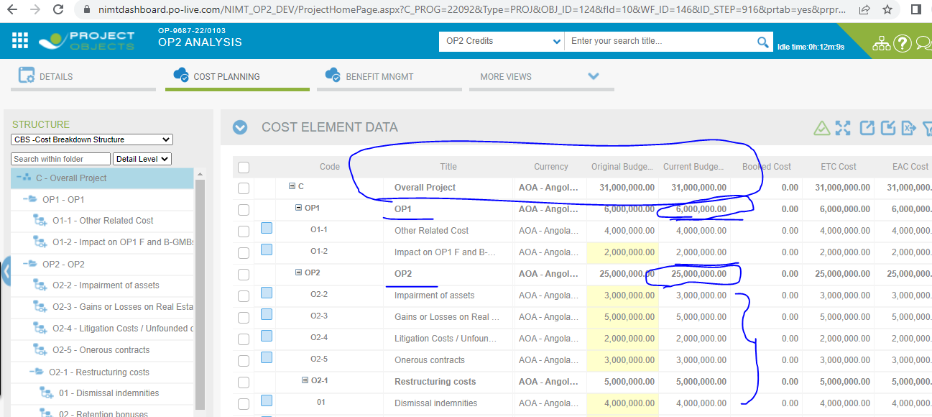

* See their OP1 and OP2 element types, User can change element type of their investment types because when we create object, the cost data elements types showing by defaults OP1 of OP1 and OP2 of OP2.

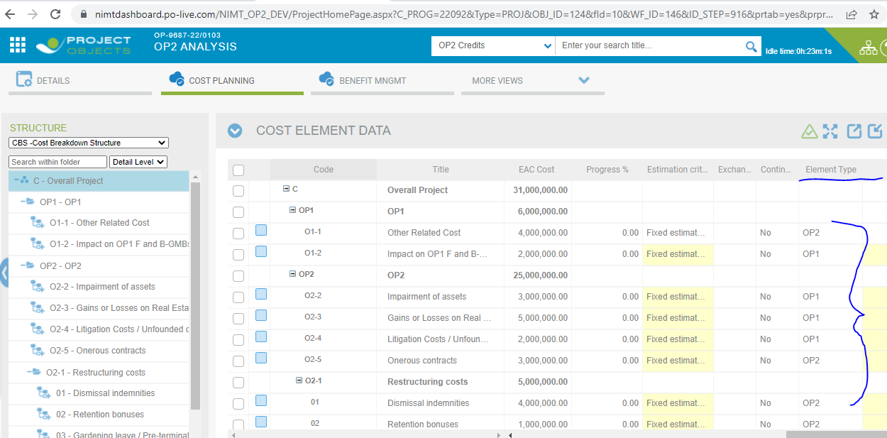

* Also see below Phasing values.

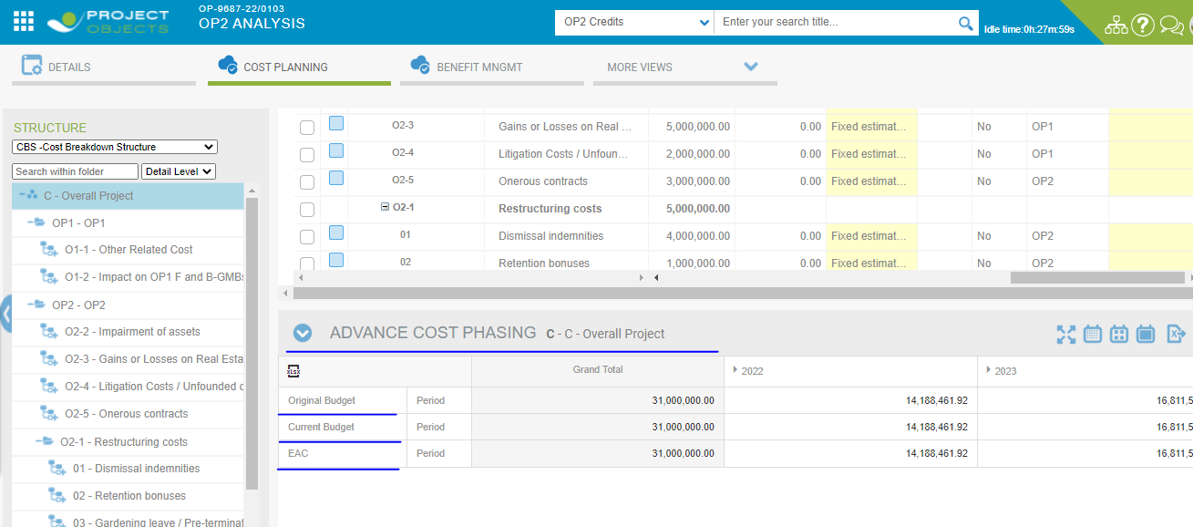

* User Can filter select type (All, OP1 and OP2) dropdown, and also see in CHF value and original value from behalf of the select type filter.

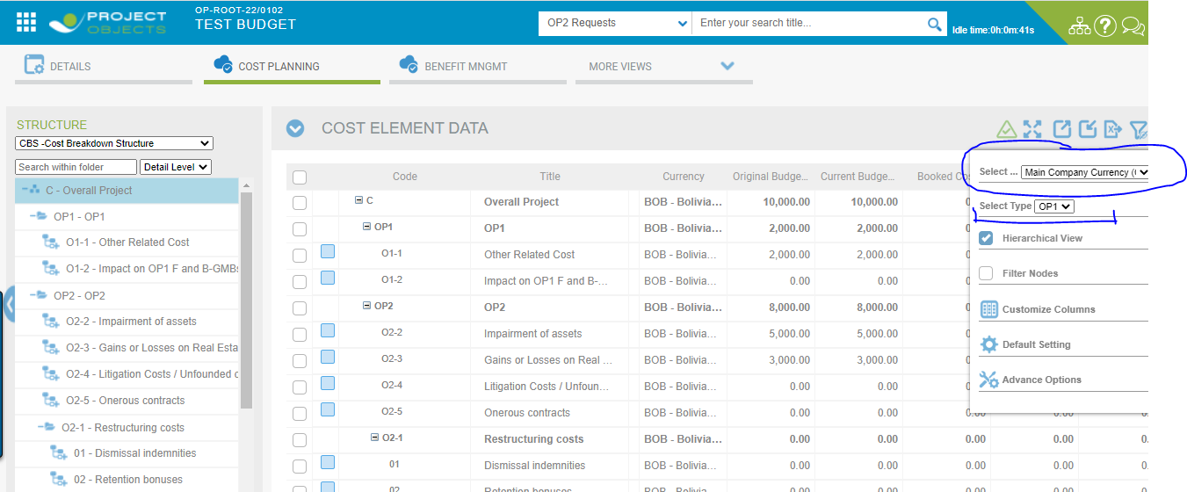

* User can change element type from Investment type edit on the right button click, It is basically change by 2 methods.

**1st method from Investment type edits on the right button click.**

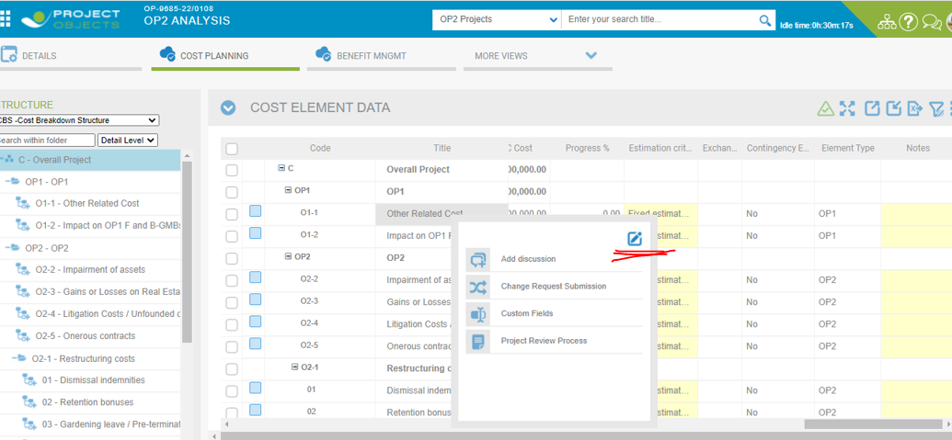

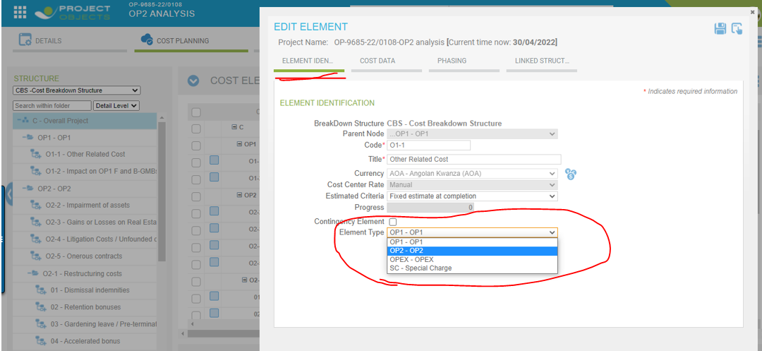

**2nd Select type of Investment type select and we click on burger menu of Cost Page and select Advance option.**

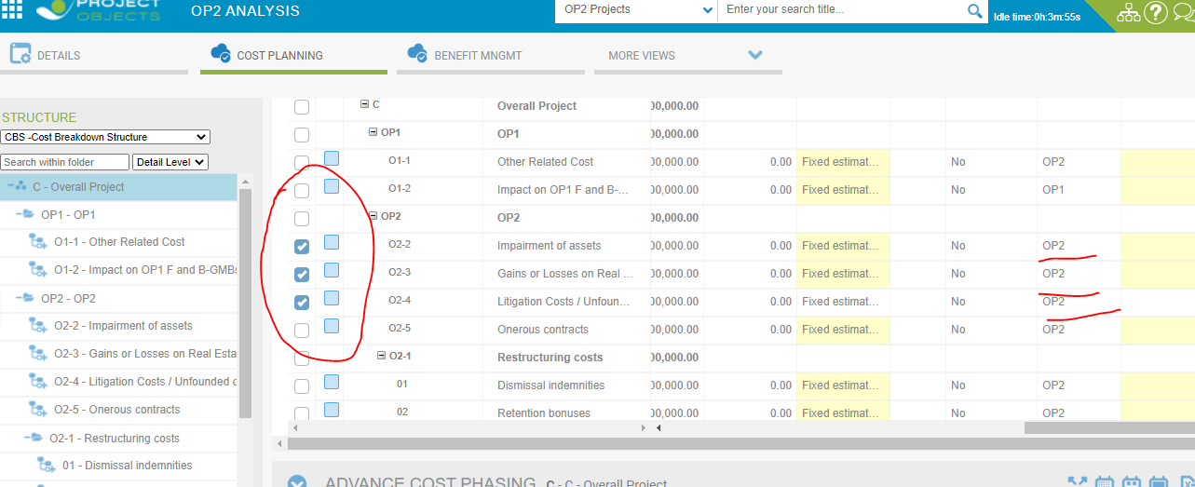

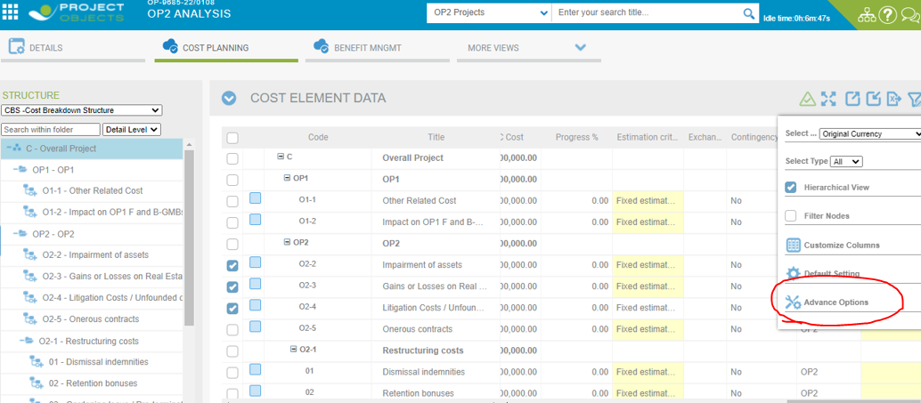

Then we select the OP1 option or OPEX then click on apply checkbox and click on save button.

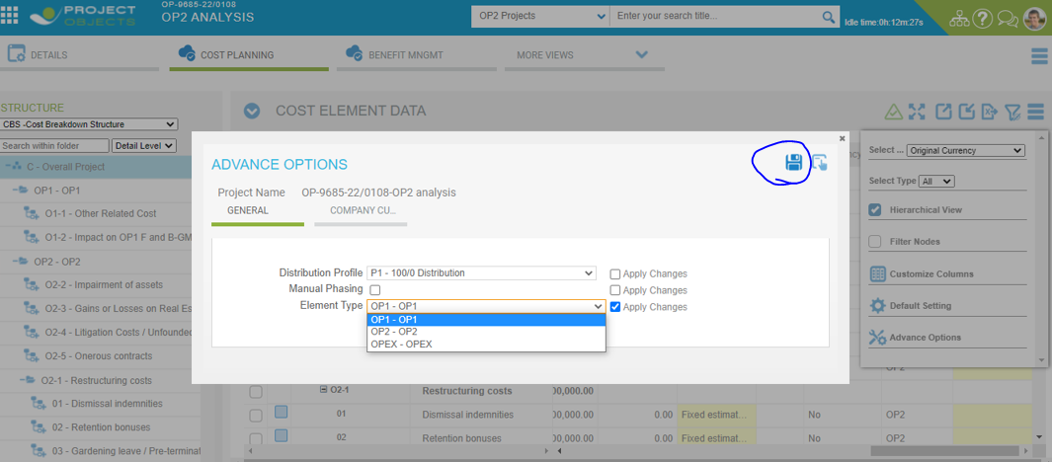

After save the type, In cost data element type is goanna changed OP2 to OP1 of there investment types.

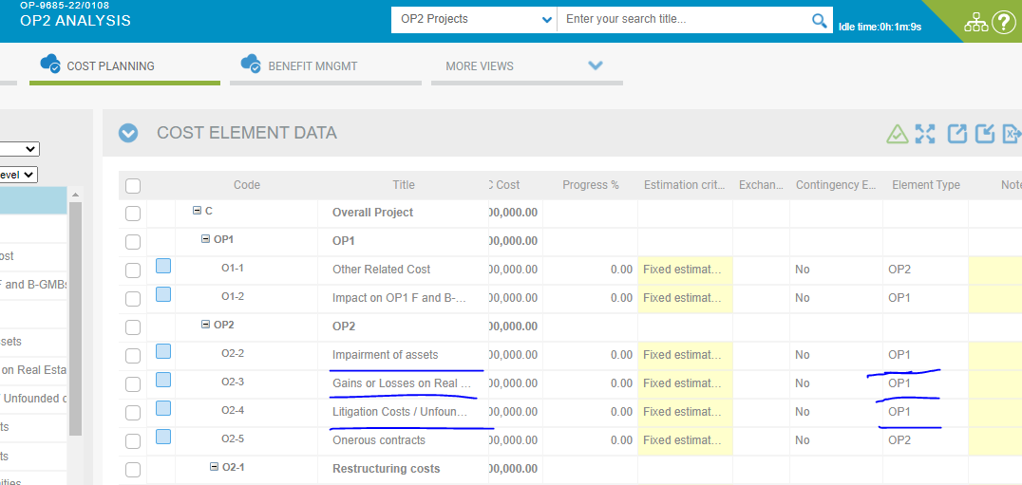

* User can customise the cost grid columns.

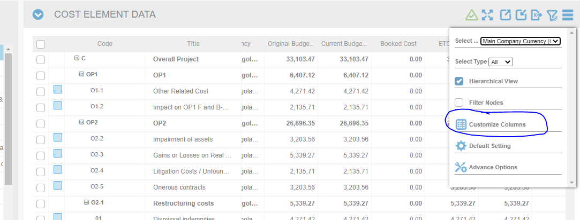

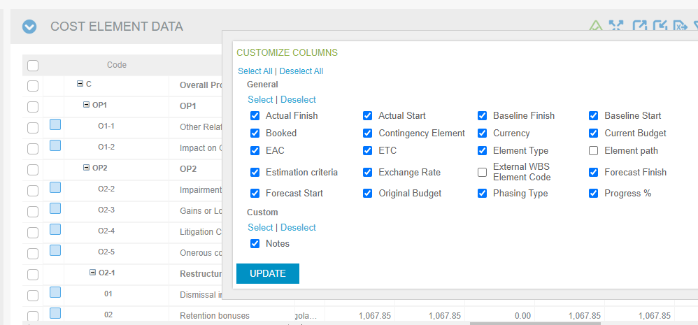

* **User can set the manual phasing from two types.**

1. **From on right button click edit option of Investment type.**
2. **From Advance Option.**

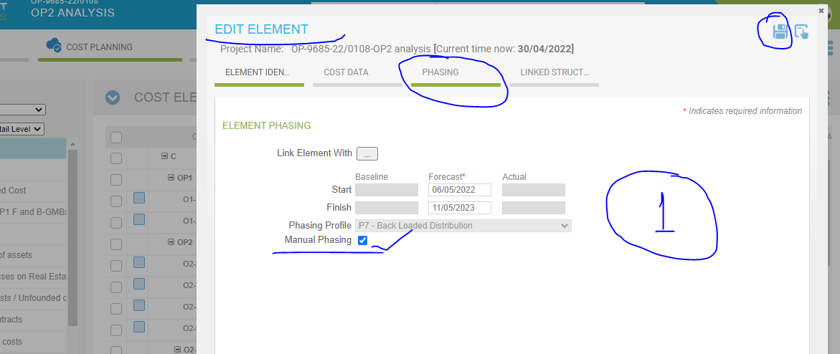

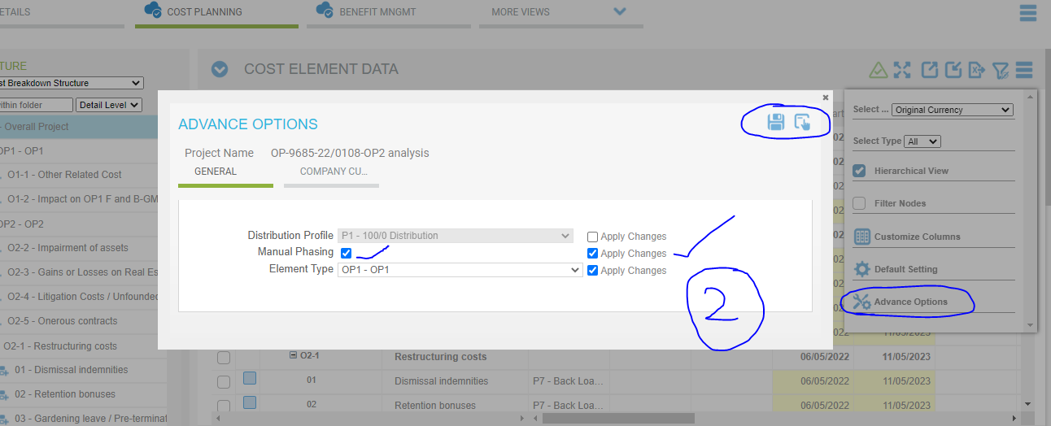

* User Can export the Excel File of Cost Grid.

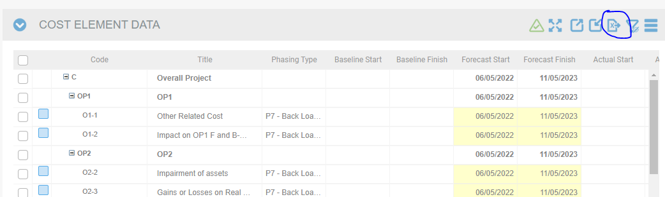

* User can filter data from cost grid.

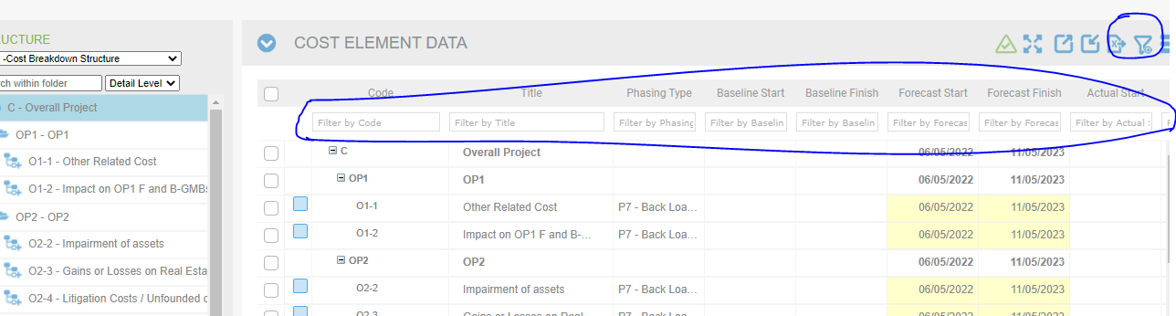

User Can set their cost element data on the basis of the OP1 and OP2 type from Company settings Project Breakdown structure.

Home Menu > Company Settings > Global Standards > Project breakdown Structure.

Here I set the sub type of **OP1 for OP2** and **OP2 for OP1** and save, User can set the sub types OP1-OP1 and OP2-OP2 accordingly also and then after this is visible for cost data in element types when we create the particular project.

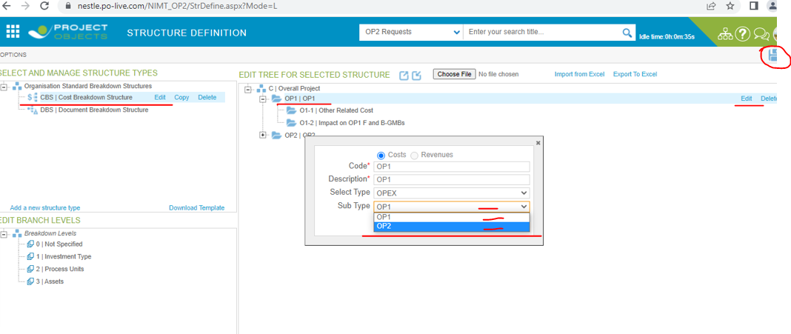

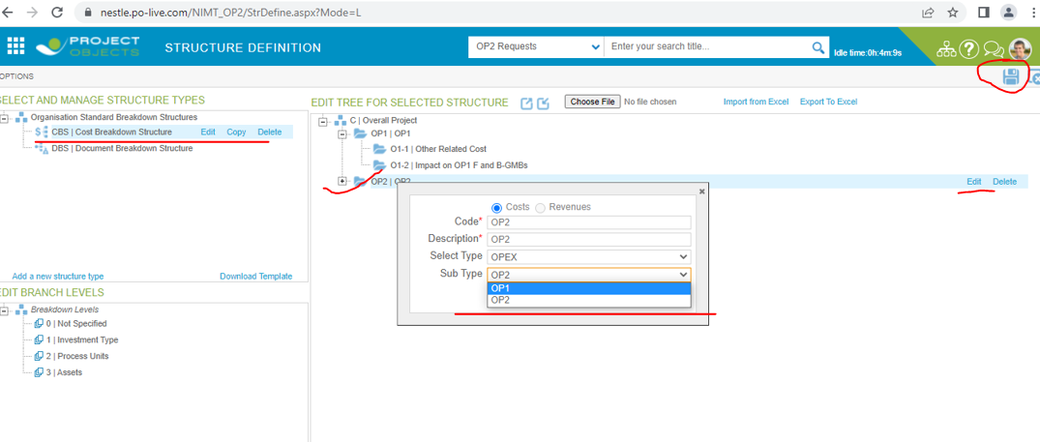

After save structure definition now, we create the new object and see the element type of OP1 and OP2. Here we are not mention the screen shot but operational function is working like that.